Exercise 2: Verifying Interactions
Scenario: You need to ensure that a method is called with specific arguments.
Steps:
1. Create a mock object.
2. Call the method with specific arguments. 3. Verify the interaction.

Implementation:
ExternalApi.java
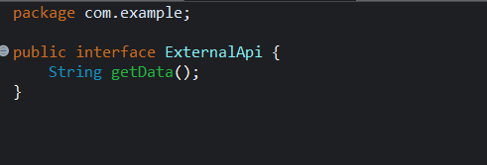

Myservice.java
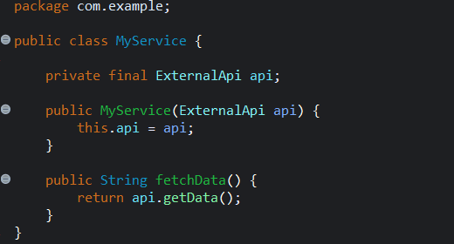

MyserviceTest.java
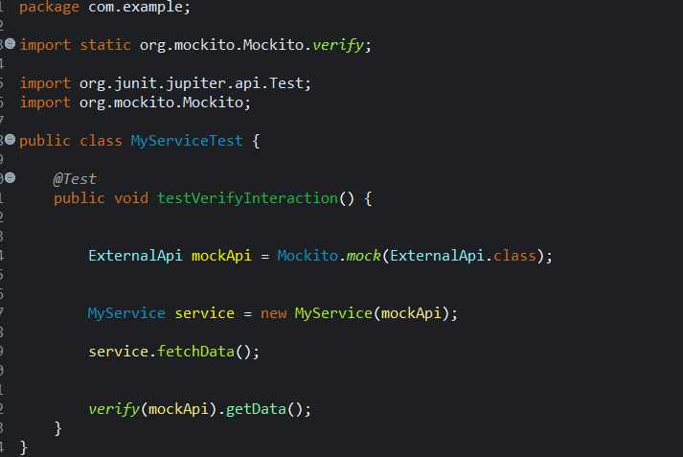

OUTPUT:
